Debilitating fear of crime among demographics
Word count – 2,414

1. Introduction
In this report I will be carrying out a secondary data analysis of the crime survey for England and Wales 2021 (CSEW 2021). The objective of this research is to investigate the strength of the relationship between various demographics and the impact fear of crime has on the respondent’s quality of life. I will do this by carrying out a regression analysis of the dependent variable “quallife” which measures how much the respondent’s own quality of life is affected by fear of crime on a 1 to 10 scale.
The focal predictor I will be using is “sex” which categorises respondent’s male or female. I have chosen this to be my focal predictor as it is a categorical variable which when dummy coded allows us to see if being female leads to an increase or decrease in the debilitative impacts of fear of crime. Pre-existing criminological research supports this showing that there are significant interactions between gender and a fear of crime. Snedker (2015) argues women report higher levels of fear surrounding crime due to their self percieved vulnerability. While Faroe (1996) argues women are also more likely to contextualise crime through the lens of sexual assault leading to a gender gap in self-reported fear of crime. However, Pohl and Buil-Gil (2023) also argue that the gender fear gap is narrowing due to increasing gender equality. Therefore, by making gender my focal predictor I will be able to provide insights into the effects fear of crime has on a person’s life depending on their gender.
I will also be using 4 control variables alongside my focal predictor those being the “age”, “ethgrp3a”, “hhinc5a2” and “educat3” representing age, ethnicity, household income, and level of education. I have chosen these control variables as these demographics heavily influence an individual’s experience of crime and will allow for an examination of intersections between them. For example, young ethnic minorities are most likely to be victimised by crime CSEW (2023), but this may not be reflected in their fear of crime. Furthermore, while low income Is generally associated with higher levels of vicitmisation CSEW (2023) shows that respondents with a degree level education are also more likely to be victimised. This leads me to hypothesise that the respondents who are young female educated ethnic minorities will be more likely to have their quality of life impacted by the fear of crime.
My data analysis will begin by producing a descriptive statistics table of my chosen variables proceeded by a variety of plots to describe the distribution of each variable. I will then produce scatterplots and correlation analysis to examine the relationship between quallife and each explanatory variable. I will also carry out a hypothesis t-test to find if the variables are statistically significant. I will then conclude my data analysis by fitting two regression models showing the relationship between quality of life and various demographics.

2. Preliminary Data analysis

2.1 Sample characteristics
Table 1 shows a descriptive statistics table of my chosen variables. Each variable has been cleaned in preparation for the regression analysis. I initiated the cleaning proccess by removing missing “NA” responses from each variable. I did this as “quallife” my dependent variable for regression analysis had 89% of responses missing. Once all missing values had been removed the sample size reduced from 33,734 to just 3,130 as shown in table 1. This may create problems for my regression models as the large reduction in sample size can weaken the strength and generalizability of results. Furthermore, according to (Dong and Peng 2013) the removal of missing data can lead to an increase in standard error and decrease in statistical power.
I have also recoded each categorical variable into dummy variables in preparation for the regression analysis. The variable “sex” was recoded 0=male 1=female, “ethgrp3a” recoded 0=white 1=non white, “educat3” recoded 0=does not hold degree or diploma 1=achieved a degree or diploma, and “hhinc5a2” recoded 0=below £31,200 1=above £31,200. I chose to recode household income at above and below £31,200 as this value was the closest to the median household income during 2021 which stood at £31,400 according to the ONS (2022). The mean of each categorical variable represents the proprotion of each category for example a mean of 0.52 in “sex” means females make up 52% of the sample.
I have also created the variable “ctr_age” from the continuous variable “age”. The new variable is the mean centred age of each respondent which is calculated by subtracting the mean of age from respondent age. This aids in regression analysis as it allows the y intercept to be interpreted correctly as it requires predictor variables to be set to 0 as it would be impossible for a respondent to have a fear of crime before they were born.
Table 1
"" | "vars" | "n" | "mean" | "sd" | "min" | "max" | "range" | "se"
"quallife" | 1 | 3130 | 2.81821086261981 | 2.12876943560102 | 1 | 10 | 9 | 0.0380501573718437
"age" | 2 | 3130 | 51.2277955271566 | 18.0890219165861 | 16 | 97 | 81 | 0.323327702435988
"mean_age" | 3 | 3130 | 51.2277955271566 | 0 | 51.2277955271566 | 51.2277955271566 | 0 | 0
"ctr_age" | 4 | 3130 | -2.19080153712127e-15 | 18.0890219165861 | -35.2277955271566 | 45.7722044728434 | 81 | 0.323327702435988
"sex" | 5 | 3130 | 0.520127795527157 | 0.499674534174838 | 0 | 1 | 1 | 0.00893130760997016
"ethgrp3a" | 6 | 3130 | 0.106709265175719 | 0.308792587466998 | 0 | 1 | 1 | 0.0055194359482434
"hhinc5a2" | 7 | 3130 | 0.474121405750799 | 0.499409633527452 | 0 | 1 | 1 | 0.00892657270953784
"educat3" | 8 | 3130 | 0.453674121405751 | 0.497928835109436 | 0 | 1 | 1 | 0.0089001045482146

2.2 Data visualisation
Figure 1 presents a variety of plots showing the univariate distirbution of each variable. Each dummy variable has been represented through a bar chart. In order to achieve this each variable had to be factorised and recategorized from the continuous binary scale. This is because continuous response categories were unable to be appropriately labbled as the x-axis was on a 0-1 scale. Furthermore, due to their binary nature continuous plots were also inappropriate. Each bar chart describes the relationship between the categorical responses through marking the percentage of each response. Sex, education, and household income hold relatively equal distributions with 45%-55% of respondents falling between one of the two categories. However, this is not the case for ethnicity in which whites hold an 88% majority in responses.
Age however is a continuous variable and did not need to be factorised before being placed into a histogram. The histogram shows age follows a normal distribution with age peaking from 30 and decreasing from the age of 60 leading to a slight skew to the right. As quallife is an ordinal categorical variable with 10 categories it was approriate to represent it in a density plot. Quallife is heavily skewed to the right with the majority of responses being below 4 on the rating scale. This suggests that either a small number of our sample fear crime or if they do fear crime, they do not experience many impacts to the quality of their lives.
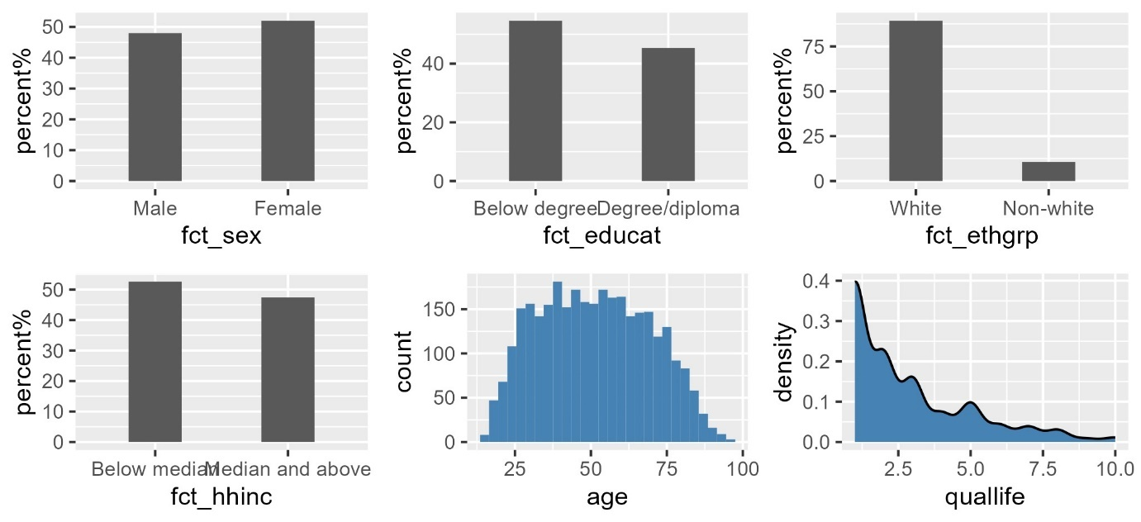
Figure1

2.2.1 Scatterplot 1 – quality of life and sex
Figure 2 presents the dependent variable quality of life measured against the focal predictor sex in a scatterplot graph. The scatterplot shows that most values in quality of life are at the lower end of the scale showing that most respondents do not experience an impact to their quality of life due to a fear of crime. A regression line has been placed into the graph in order to show the correlation between the variables. The line is placed at the value 2.5 for quality of life and slightly raises to the value 3 when running along the x-axis. This shows that there is a very weak but positve correlation between being female and quality of life due to a fear of crime.
Due to my focal predictor being a categorical variable the data points are focused onto two values rather than being spread out across the entirety of the x-axis as a continuous varibale would be. This can make categorical scatter graphs difficult to interpret. To treat this, I used the jitter effect which adds random noise to the scatter graph. This improves readability and allows individual markers to be more easily discerned.
Figure 2
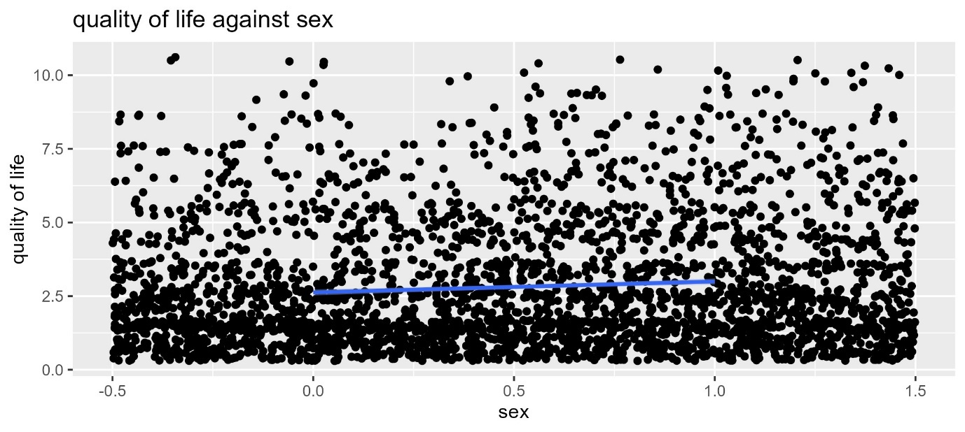

2.2.2 Scatter plot 2 – quality of life and age
Figure 3 presents the dependent variable quality of life measured agaisnt the contorl variable age. Similarly to figure 2 figure 3 also shows that measures of quallife are distributed towards the end of the scale as shown by the grouping towards the bottom of the y-axis. The regression line starts at and quality of life rating of 3 and decreases to 2.7 as age increases. This shows that unlike sex, age is negatively associated with a debilitating fear of crime however this association is also extremely weak. Unlike sex age did not require the jitter function along the x-axis. This is because age is a non-binary continuous variable meaning points are spread more evenly throughout the graph.

Figure 3
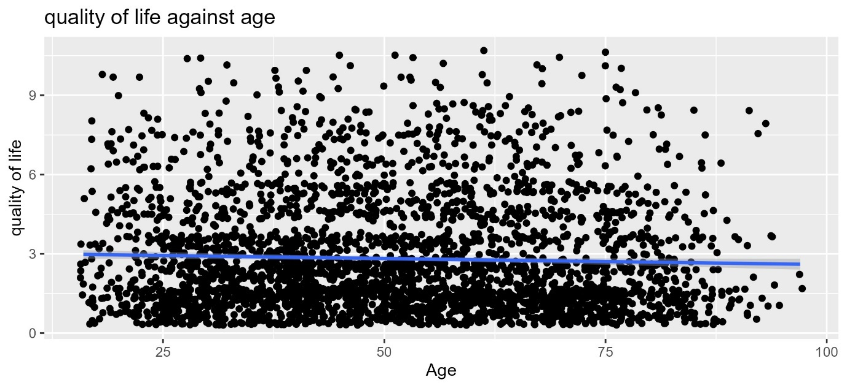

2.3 Correlation analysis
Table 2 represents the correlation between each explanatory variable and the dependent variable quality of life. The correlations are rated based on Pearsons’s correlation coeffcient. Pearsons’s coefficient shows both strength and direction of the correlation between two variables. The r value ranges from -1 to 1 negative numbers representing a negative correlation while positve numbers show a positive correlation. The predictor variables are all shown to have weak correlations with the dependent variable the strongest being ethnicity with just 0.16. whereas age hold the weakest correlation with quality of life with r = -0.03. The variables sex, age, and ethnicity do match my hypothesis that these factors correlate with a greater quality of life impact due to a fear of crime. However, education does not match my hypothesis as despite being more likely to be vicitmised there is a negative correlation between having a degree and a debilitating fear of crime.
Table 2
"" | "variable" | "correlation"
"1" | "sex" | 0.0874180288621101
"2" | "age" | -0.0389360364778189
"3" | "ethnicity" | 0.167109322825552
"4" | "education" | -0.0780481324674106
"5" | "household income" | -0.0854419297022997

2.4 T-test
For conducting the t-test I chose the predictor variable sex as it is both categorical and the focal predictor for the quality of life of respondents. The aim of the t test is to reject the null hypothesis that there is no statistically significant difference in the quality of life experienced between the two genders. The null hypothesis can be rejected when the p-value is <0.05 as this means that the chance of these sample means occuring when the null hypothesis is true is less than 5%. However, it is to be noted that a p-value of 0.05 is arbitrary and a low p value can still statistically insignificant. The results of the test are shown below.
Welch Two Sample t-test

data: quallife by sex
t = -4.9339, df = 3119.9, p-value = 8.481e-07
alternative hypothesis: true difference in means between group 0 and group 1 is not equal to 0
95 percent confidence interval:
-0.5204296 -0.2244265
sample estimates:
mean in group 0 mean in group 1

The p-value is shown to be <0.05 meaning the alternative hypothesis that there is a statistically significant difference in quality of life between the two genders can be accepted. Two sample tests can also be conducted on the other categorical variables and can tell us whether they are statistically significant for the regression analysis.
ethnicity
Welch Two Sample t-test

data: quallife by ethgrp3a
t = -7.7328, df = 381.64, p-value = 9.453e-14
alternative hypothesis: true difference in means between group 0 and group 1 is not equal to 0
95 percent confidence interval:
-1.4449507 -0.8591021
sample estimates:
mean in group 0 mean in group 1
2.695279 3.847305

education
Welch Two Sample t-test

data: quallife by educat3
t = 4.4468, df = 3127.1, p-value = 9.021e-06
alternative hypothesis: true difference in means between group 0 and group 1 is not equal to 0
95 percent confidence interval:
0.1865466 0.4808037
sample estimates:
mean in group 0 mean in group 1
2.969591 2.635915

Household income
Welch Two Sample t-test

data: quallife by hhinc5a2
t = 4.8421, df = 3107.1, p-value = 1.347e-06
alternative hypothesis: true difference in means between group 0 and group 1 is not equal to 0
95 percent confidence interval:
0.2167255 0.5116792
sample estimates:
mean in group 0 mean in group 1
2.990887 2.626685

For each of these variables the p-values are <0.05 meaning their null hypotheses are rejected and there is a statistically significant difference in the means of each category. This is further supported by the 95% confidence intervals in which none of them cross zero meaning the chance of the means being the same is less than 95%.

3. Regression analysis

3.1 focal predictor
I will begin my regression analysis by focusing on my focal predictor and analysing the effects it has on the dependent variable quality of life.
Table 3
How much is YOUR OWN
quality of life affected
by fear of crime
Predictors | Estimates | CI | p
(Intercept) | 2.62 | 2.52 – 2.73 | <0.001
Adult number  1(respondent):Sex | 0.37 | 0.22 – 0.52 | <0.001
Observations | 3130
R² / R² adjusted | 0.008 / 0.007

When all predictors are 0 the dependent variable will intercept the y axis at the value of 2.62 with a confidence interval from 2.53 – 2.73. The confidence interval shows the range of where the true value may lie. Both variables are shown to be statistically significant. The slope estimate of the focal predictor is 0.37 which means the dependent variable will increase in value by 0.37 for every one unit increase in predictor variable. The R*2 adjusted value is 0.007. once these are converted into percentages the rate of variance explained by the model. In this case the R*2 adjusted is small and our model only explains 0.7% of the variance. In order for more variance to be explained additional predictor variables may be needed.

3.2 control variables
This second linear model will include both my focal predictor and control variables when explain variance in quality of life.
Tabel 4
How much is YOUR OWN
quality of life affected
by fear of crime
Predictors | Estimates | CI | p
(Intercept) | 2.77 | 2.63 – 2.91 | <0.001
Adult number  1(respondent):Sex | 0.38 | 0.23 – 0.53 | <0.001
ctr age | -0.00 | -0.01 – -0.00 | 0.035
Respondent education(5  categories) | -0.35 | -0.51 – -0.20 | <0.001
Ethnic  group(white/non-white) | 1.19 | 0.95 – 1.42 | <0.001
Total household income(5  bands) | -0.24 | -0.40 – -0.09 | 0.003
Observations | 3130
R² / R² adjusted | 0.049 / 0.048

When all predictors are set to 0 the dependent variable intercepts the y axis at 2.77 with a confidence interval +/- 0.14. The control variables show varying influences on the dependent variable. Education level has the strongest negative slope in which quality of life decreases by -0.35 for every unit increase in education. This shows that those with a degree level of education are less likely to have their life impacted by a fear of crime. Ethnicity holds the strongest positive slope and shows that for every one unit increase in ethnicity quality of life rating increases by 1.19. This means that non white ethnic minorities are more likely to have the quality of there life impacted by a fear of crime. The adjusted R*2 values for this model are significantly higher than the previous model yet is still small overall and only accounts for 4.8% of the variance in the dependent variable quality of life.

4. Discussion and Conclusion
In this report I have carried out a regression analysis on data from the CSEW (2021) showing how a respondent’s membership to various demographics can influence how a fear of crime impacts the quality of there life. The regression analysis was able to explain 4.8% of the variation however some variables were more impactful than others. For example, female ethnic minorities have a much higher likelihood of experiencing negative effects due to fear of crime. This may be due to a percived lack of social power. For example, these groups may have less trust in the police meaning they feel like they are less likely to recive support when victimised by crime. Furthermore, demographics such as highly educated and having above median household income experience less quality of life impacts due to a fear of crime. This could be due to these groups holding more social power and living in safer areas with less economic deprivation and crime.
However, there are limitations within my statistical report. Due to high levels of missing values in the variable “quallife” the sample size reduced drastically making the model less accurate and generalizable. Furthermore, the regression models themselves explain less than 5% of the variation in quality of life meaning this model will be limited in the outcomes it can predict.

References
Dong Y, Peng CY. Principled missing data methods for researchers. Springerplus. 2013 May 14;2(1):222. doi: 10.1186/2193-1801-2-222. PMID: 23853744; PMCID: PMC3701793.
Ferraro, Kenneth F. “Women’s Fear of Victimization: Shadow of Sexual Assault?” Social Forces 75, no. 2 (1996): 667–90. https://doi.org/10.2307/2580418.

Office for national statistics (ONS) (2021) ‘Crime Survey for England and Wales Technical Report 2019/20’
Office for national statistics (ONS), released 28 March 2022, ‘average household income, uk financial year ending 2021’.
Office for National Statistics (ONS), released 6 March 2024, ONS website, article, Crime in England and Wales, victim characteristics: year ending March 2023
Pohl, Sophie & Buil-Gil, David. (2023). ‘The Drop in Worry about Crime and Its Gender Gap: Trends in England and Wales from 1998 to 2019/2020.’ CrimRxiv. 10.21428/cb6ab371.8d50382d.
Snedker, Karen. (2012). ‘Explaining the Gender Gap in Fear of Crime: Assessments of Risk and Vulnerability Among New York City Residents.’ Feminist Criminology - FEM CRIMINOL. 7. 75-111. 10.1177/1557085111424405.

Appendix (R code)
setwd("C:/Users/jopit/OneDrive - The University of Manchester/R_AST/Report")
getwd()
## [1] "C:/Users/jopit/OneDrive - The University of Manchester/R_AST/Report"
pacman::p_load(haven, tidyverse, janitor, tableone, ggplot2, gridExtra, psych,
lubridate, sjPlot, magrittr, expss, modelsummary, broom, car,
jtools, knitr, mice)
load("CSEW_DATA_2019-20.RData")
keepvar <- c("quallife", "sex", "age", "ethgrp3a", "hhinc5a2", "educat3")
var <- df[, keepvar]
var %>% tabyl(quallife)
## quallife n percent valid_percent
## 1 1429 0.0423608229 0.380965076
## 2 745 0.0220845438 0.198613703
## 3 525 0.0155629335 0.139962677
## 4 243 0.0072034150 0.064782725
## 5 347 0.0102863580 0.092508664
## 6 141 0.0041797593 0.037589976
## 7 132 0.0039129661 0.035190616
## 8 113 0.0033497362 0.030125300
## 9 31 0.0009189542 0.008264463
## 10 45 0.0013339657 0.011996801
## NA 29983 0.8888065453 NA
var %>% tabyl(sex)
## sex n percent
## 1 15505 0.4596253
## 2 18229 0.5403747
var %>% tabyl(age)
## age n percent valid_percent
## 16 133 3.942610e-03 3.957744e-03
## 17 174 5.158001e-03 5.177801e-03
## 18 205 6.076955e-03 6.100283e-03
## 19 216 6.403036e-03 6.427615e-03
## 20 213 6.314104e-03 6.338343e-03
## 21 254 7.529495e-03 7.558399e-03
## 22 287 8.507737e-03 8.540396e-03
## 23 291 8.626312e-03 8.659426e-03
## 24 329 9.752772e-03 9.790210e-03
## 25 383 1.135353e-02 1.139711e-02
## 26 375 1.111638e-02 1.115905e-02
## 27 443 1.313215e-02 1.318256e-02
## 28 477 1.414004e-02 1.419432e-02
## 29 470 1.393253e-02 1.398601e-02
## 30 521 1.544436e-02 1.550365e-02
## 31 545 1.615581e-02 1.621782e-02
## 32 539 1.597795e-02 1.603928e-02
## 33 544 1.612616e-02 1.618807e-02
## 34 524 1.553329e-02 1.559292e-02
## 35 592 1.754906e-02 1.761643e-02
## 36 585 1.734155e-02 1.740812e-02
## 37 546 1.618545e-02 1.624758e-02
## 38 548 1.624474e-02 1.630710e-02
## 39 541 1.603723e-02 1.609879e-02
## 40 603 1.787514e-02 1.794376e-02
## 41 494 1.464398e-02 1.470019e-02
## 42 519 1.538507e-02 1.544413e-02
## 43 525 1.556293e-02 1.562268e-02
## 44 482 1.428826e-02 1.434310e-02
## 45 527 1.562222e-02 1.568219e-02
## 46 500 1.482184e-02 1.487874e-02
## 47 550 1.630403e-02 1.636661e-02
## 48 539 1.597795e-02 1.603928e-02
## 49 553 1.639296e-02 1.645588e-02
## 50 614 1.820122e-02 1.827109e-02
## 51 539 1.597795e-02 1.603928e-02
## 52 518 1.535543e-02 1.541437e-02
## 53 574 1.701547e-02 1.708079e-02
## 54 603 1.787514e-02 1.794376e-02
## 55 625 1.852730e-02 1.859842e-02
## 56 593 1.757870e-02 1.764618e-02
## 57 585 1.734155e-02 1.740812e-02
## 58 567 1.680797e-02 1.687249e-02
## 59 562 1.665975e-02 1.672370e-02
## 60 580 1.719334e-02 1.725934e-02
## 61 522 1.547400e-02 1.553340e-02
## 62 540 1.600759e-02 1.606904e-02
## 63 491 1.455505e-02 1.461092e-02
## 64 519 1.538507e-02 1.544413e-02
## 65 605 1.793443e-02 1.800327e-02
## 66 516 1.529614e-02 1.535486e-02
## 67 569 1.686726e-02 1.693200e-02
## 68 522 1.547400e-02 1.553340e-02
## 69 514 1.523685e-02 1.529534e-02
## 70 557 1.651153e-02 1.657491e-02
## 71 541 1.603723e-02 1.609879e-02
## 72 626 1.855695e-02 1.862818e-02
## 73 485 1.437719e-02 1.443238e-02
## 74 414 1.227248e-02 1.231960e-02
## 75 590 1.748977e-02 1.755691e-02
## 76 532 1.577044e-02 1.583098e-02
## 77 362 1.073101e-02 1.077221e-02
## 78 367 1.087923e-02 1.092099e-02
## 79 340 1.007885e-02 1.011754e-02
## 80 349 1.034565e-02 1.038536e-02
## 81 336 9.960277e-03 9.998512e-03
## 82 282 8.359519e-03 8.391608e-03
## 83 280 8.300231e-03 8.332093e-03
## 84 258 7.648070e-03 7.677429e-03
## 85 208 6.165886e-03 6.189555e-03
## 86 161 4.772633e-03 4.790954e-03
## 87 161 4.772633e-03 4.790954e-03
## 88 127 3.764748e-03 3.779200e-03
## 89 128 3.794391e-03 3.808957e-03
## 90 72 2.134345e-03 2.142538e-03
## 91 68 2.015770e-03 2.023508e-03
## 92 49 1.452540e-03 1.458116e-03
## 93 39 1.156104e-03 1.160542e-03
## 94 30 8.893105e-04 8.927243e-04
## 95 16 4.742989e-04 4.761196e-04
## 96 17 5.039426e-04 5.058771e-04
## 97 10 2.964368e-04 2.975748e-04
## 98 8 2.371495e-04 2.380598e-04
## 99 3 8.893105e-05 8.927243e-05
## 100 3 8.893105e-05 8.927243e-05
## 104 1 2.964368e-05 2.975748e-05
## NA 129 3.824035e-03 NA
var %>% tabyl(ethgrp3a)
## ethgrp3a n percent valid_percent
## 1 29918 0.886879706 0.889543
## 2 3715 0.110126282 0.110457
## NA 101 0.002994012 NA
var %>% tabyl(hhinc5a2)
## hhinc5a2 n percent valid_percent
## 1 3544 0.1050572 0.1253182
## 2 3134 0.0929033 0.1108204
## 3 3024 0.0896425 0.1069307
## 4 5201 0.1541768 0.1839109
## 5 13377 0.3965435 0.4730198
## NA 5454 0.1616766 NA
var %>% tabyl(educat3)
## educat3 n percent valid_percent
## 1 5992 0.177624948 0.17859378
## 2 5969 0.176943143 0.17790826
## 3 5968 0.176913500 0.17787845
## 4 13994 0.414833699 0.41709636
## 5 1628 0.048259916 0.04852314
## NA 183 0.005424794 NA
var <- var %>% drop_na()
var$sex [var$sex == 1] <- 0
var$sex [var$sex == 2] <- 1
var$ethgrp3a [var$ethgrp3a == 1] <- 0
var$ethgrp3a [var$ethgrp3a == 2] <- 1
var$educat3 [var$educat3 == 1] <- 0
var$educat3 [var$educat3 == 2] <- 0
var$educat3 [var$educat3 == 3] <- 0
var$educat3 [var$educat3 == 4] <- 1
var$educat3 [var$educat3 == 5] <- 0
var$hhinc5a2 [var$hhinc5a2 == 1] <- 0
var$hhinc5a2 [var$hhinc5a2 == 2] <- 0
var$hhinc5a2 [var$hhinc5a2 == 3] <- 0
var$hhinc5a2 [var$hhinc5a2 == 4] <- 0
var$hhinc5a2 [var$hhinc5a2 == 5] <- 1
var$mean_age <- mean(var$age)
var <- var %>%
mutate(ctr_age = age - mean_age) %>%
select(quallife, age, mean_age, ctr_age, everything())
write_rds(var, file = "cleaned.rds")
dta <- read_rds("cleaned.rds")
tab <- describe(dta, fast = TRUE)
view (tab)
write.csv(tab, "descriptivetab.csv")
dta$fct_sex <- factor(dta$sex,
labels = c("Male", "Female"))
dta$fct_educat <- factor(dta$educat3,
labels = c("Below degree", "Degree/diploma"))
dta$fct_ethgrp <- factor(dta$ethgrp3a,
labels = c("White", "Non-white"))
dta$fct_hhinc <- factor(dta$hhinc5a2,
labels = c("Below median", "Median and above"))
a <- dta %>% tabyl(fct_sex)
b <- dta %>% tabyl(fct_ethgrp)
c <- dta %>% tabyl(fct_hhinc)
d <- dta %>% tabyl(fct_educat)
sp <- ggplot(a, aes(x = fct_sex, y = percent*100)) +
geom_bar(stat = "identity", width = 0.4) + labs(y = "percent%")
ep <- ggplot(d, aes(x = fct_educat, y = percent*100)) +
geom_bar(stat = "identity", width = 0.4) + labs(y = "percent%")
tp <- ggplot(b, aes(x = fct_ethgrp, y = percent*100)) +
geom_bar(stat = "identity", width = 0.4) + labs(y = "percent%")
hp <- ggplot(c, aes(x = fct_hhinc, y = percent*100)) +
geom_bar(stat = "identity", width = 0.4) + labs(y = "percent%")
ap <- ggplot(dta, aes(x = age)) +
geom_histogram(binwidth = 3, fill = "steelblue")
qp <- ggplot(dta, aes(x = quallife)) +
geom_density(fill = "steelblue")
ggp <-
grid.arrange(sp, ep, tp, hp, ap, qp, ncol = 3 , nrow = 2)
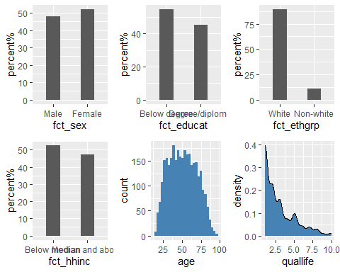
ggsave(ggp, file = "plots.png")
## Saving 5 x 4 in image
ss <- ggplot(dta,aes(x = sex, y = quallife)) +
geom_jitter(width = 0.5, height = 0.7) +
geom_smooth(method =lm) +
labs(x = "sex", y = "quality of life", title = "quality of life against sex")
sa <- ggplot(dta,aes(x = age, y = quallife)) +
geom_jitter(height = 0.7) +
geom_smooth(method = lm) +
labs(x = "Age", y = "quality of life", title = "quality of life against age")
ggsave(ss, file = "sex_scatter.png")
## Saving 5 x 4 in image
## `geom_smooth()` using formula = 'y ~ x'
ggsave(sa, file = "age_scatter.png")
## Saving 5 x 4 in image
## `geom_smooth()` using formula = 'y ~ x'
cor <- c(cor(dta$sex, dta$quallife, use = "complete.obs"),
cor(dta$age, dta$quallife, use = "complete.obs"),
cor(dta$ethgrp3a, dta$quallife, use = "complete.obs"),
cor(dta$educat3, dta$quallife, use = "complete.obs"),
cor(dta$hhinc5a2, dta$quallife, use = "complete.obs"))
cor_var <- c("sex", "age", "ethnicity", "education", "household income")
cor_tab <- tibble(variable = cor_var,
correlation = cor)
write.csv(cor_tab, "correlation table.csv")
t.test(quallife ~ sex, dta)
##
## Welch Two Sample t-test
##
## data: quallife by sex
## t = -4.9339, df = 3119.9, p-value = 8.481e-07
## alternative hypothesis: true difference in means between group 0 and group 1 is not equal to 0
## 95 percent confidence interval:
## -0.5204296 -0.2244265
## sample estimates:
## mean in group 0 mean in group 1
## 2.624501 2.996929
t.test(quallife ~ ethgrp3a, dta)
##
## Welch Two Sample t-test
##
## data: quallife by ethgrp3a
## t = -7.7328, df = 381.64, p-value = 9.453e-14
## alternative hypothesis: true difference in means between group 0 and group 1 is not equal to 0
## 95 percent confidence interval:
## -1.4449507 -0.8591021
## sample estimates:
## mean in group 0 mean in group 1
## 2.695279 3.847305
t.test(quallife ~ educat3, dta)
##
## Welch Two Sample t-test
##
## data: quallife by educat3
## t = 4.4468, df = 3127.1, p-value = 9.021e-06
## alternative hypothesis: true difference in means between group 0 and group 1 is not equal to 0
## 95 percent confidence interval:
## 0.1865466 0.4808037
## sample estimates:
## mean in group 0 mean in group 1
## 2.969591 2.635915
t.test(quallife ~ hhinc5a2, dta)
##
## Welch Two Sample t-test
##
## data: quallife by hhinc5a2
## t = 4.8421, df = 3107.1, p-value = 1.347e-06
## alternative hypothesis: true difference in means between group 0 and group 1 is not equal to 0
## 95 percent confidence interval:
## 0.2167255 0.5116792
## sample estimates:
## mean in group 0 mean in group 1
## 2.990887 2.626685
model.1 <- lm(formula = quallife ~ sex, data = dta)
tab_model(model.1)

How much is YOUR OWNquality of life affectedby fear of crime
Predictors
Estimates
CI
p
(Intercept)
2.62
2.52 – 2.73
<0.001
Adult number1(respondent):Sex
0.37
0.22 – 0.52
<0.001
Observations
3130
R2 / R2 adjusted
0.008 / 0.007
model.2 <- lm(formula = quallife ~ sex + ctr_age + educat3 + ethgrp3a + hhinc5a2, data = dta)
tab_model(model.2)

How much is YOUR OWNquality of life affectedby fear of crime
Predictors
Estimates
CI
p
(Intercept)
2.77
2.63 – 2.91
<0.001
Adult number1(respondent):Sex
0.38
0.23 – 0.53
<0.001
ctr age
-0.00
-0.01 – -0.00
0.035
Respondent education(5categories)
-0.35
-0.51 – -0.20
<0.001
Ethnicgroup(white/non-white)
1.19
0.95 – 1.42
<0.001
Total household income(5bands)
-0.24
-0.40 – -0.09
0.003
Observations
3130
R2 / R2 adjusted
0.049 / 0.048

